# 2023 MAYOR’S COMMUNITY SAFETY AWARDS

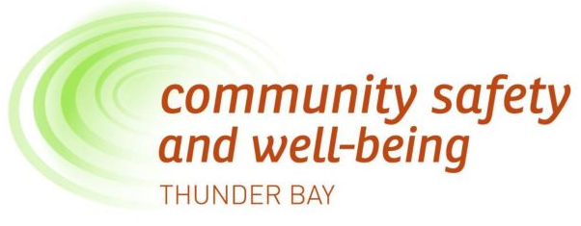

**Do you know an individual or group making Thunder Bay a safer place to live, work and play?**

Community safety and well-being are top priorities to enhance the quality of life for all Thunder Bay residents. The Mayor’s Community Safety Awards, presented by the Community Safety & Well-Being Thunder Bay and The City of Thunder Bay, celebrates individuals and groups helping to build a safer and healthier community.

### Submit your nomination by Friday, October 6, 2023 at 4:30 p.m.

* ***Community Hero Award***

For an outstanding individual effort that contributes to a safer community.

* ***Young Leader Award***

For an outstanding contribution by a youth who demonstrates and encourages active participation in community safety. The youth is a leader in a project in their community.

## Outstanding Community Project Award

For outstanding results in community safety or crime prevention through partnership and collaboration. Up to four projects may be awarded.

**AWARD RECIPIENT RECOGNITION**

* Official certificate recognizing the award-winning work
* Recognition at Awards Ceremony on November 6, 2023
* Record of accomplishment published in Awards Souvenir Program
* Feature in 2023 Mayor’s Community Safety Awards Video
* Recognition in CSWB Newsletter and on City of Thunder Bay website
* Outstanding Community Projects receive a $1000 cash award



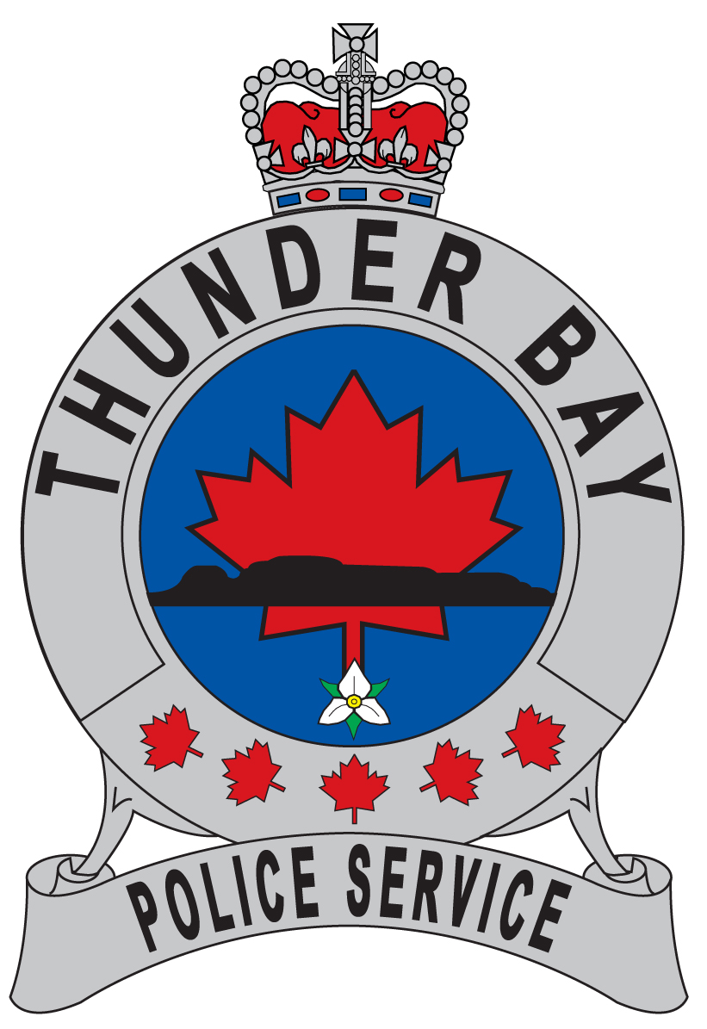









### SELECTION PROCESS

**Community Safety & Well-Being Thunder Bay Guiding Principles**

**Equity**

We understand that meeting the basic needs of people in our community is critical. These needs include equitable access to services, supports and opportunities to thrive and participate in decision making.

**Empathy**

Cultivating empathy creates connections that break down the “us and them” divide, and helps to build compassion for the challenges, circumstances and risks of diverse people in our community. We value dignity and respect and support others without judgment. We are open, hones and caring in our relationships.

**Efficacy**

We know that safety and wee-being requires a community effort based on evidence and encourages upstream investment in the protective factors that keep people safe and well. We work in partnership and build on the strengths, skills and capacities of our community to bridge gaps and solve problems.

### Equity

We understand that meeting the basic needs of people in our community is critical. These needs include equitable access to services, supports and opportunities to thrive and participate in decision making.

### Empathy

Cultivating empathy creates connections that break down the “us and them” divide, and helps to build compassion for the challenges, circumstances and risks of diverse people in our community. We value dignity and respect and support others without judgment. We are open, honest and caring in our relationships.

### Efficacy

We know that safety and well-being requires a community effort based on evidence, and encourages upstream investment in the protective factors that keep people safe and well. We work in partnership and build on the strengths, skills and capacities of our community to bridge gaps and solve problems.

Selection for an award will be based on how strongly the nominee embodies the Community Safety & Well-Being Thunder Bay Guiding Principles.

The Selection Committee will be comprised of members of the Community Safety & Well-Being Roundtable. Members of the Selection Committee will declare any affiliations and/or conflicts of interest in reviewing nominations. The decisions of the Committee will be final.

### NOMINATION CRITERIA

If a nominee has previously received a Mayor’s Community Safety Award they are not eligible.

Outstanding Community Projects must be initiated by a Thunder Bay-based individual or organization and benefit Thunder Bay communities. Projects operated by the City of Thunder Bay, its agencies, Boards and Commissions and/or other orders of Government are not eligible. Organizations may submit more than one project; however, only one project per organization will be selected for an award.

### NOMINATION FORM DEADLINE

The nomination form can be printed and completed by hand. All pages of the completed nomination form must be received by **Friday, October 6, 2023 at 4:30pm** to be eligible**.**

 **THANK YOU TO OUR SPONSORS**

[](https://www.google.ca/url?sa=i&rct=j&q=&esrc=s&source=images&cd=&cad=rja&uact=8&ved=2ahUKEwj37tOor8rdAhULiIMKHfvXDEkQjRx6BAgBEAU&url=https%3A%2F%2Fwww.sdmmag.com%2Farticles%2F91160-honeywell-adds-apex-investigation-security-as-authorized-dealer&psig=AOvVaw0Yrq0RXgHRPdmUuUecbfcv&ust=1537559952043241) A red and grey logo

# 2023 MAYOR’S COMMUNITY SAFETY AWARDS









***NOMINATION FORM***

**ALL SECTIONS MUST BE COMPLETED TO BE ELIGIBLE**

|  |  |  |
| --- | --- | --- |
| **1. NOMINEE INFORMATION** |  | |
| Name:  Organization: Address: | Title *(if applicable)*:  City: | Postal Code: |
| Phone: | Email: |  |

### YOUR INFORMATION (AS THE NOMINATOR)

|  |  |  |
| --- | --- | --- |
| Name: | Title *(if applicable)*: |  |
| Organization: |  |
| Address: | City: | Postal Code: |
| Phone: | Email: |  |

* 1. **SUGGESTED AWARD CATEGORY (check or circle one):**

**Community Hero Young Leader Outstanding Community Project**

3

### CONTRIBUTION (Provide a brief overview of the nominee’s contribution to community safety. Who benefits?)

* 1. **COMMITMENT (Describe how the nominee contributes to community safety in terms of duration and impact.)**
  2. **COLLABORATION (Describe how the nominee encourages and/or develops partnerships for building stronger, safer communities with local business, organizations, residents, schools or other.)**
  3. **SUBMIT YOUR NOMINATION**

Additional information such as pamphlets, related reports, and newspaper clippings will be accepted. If more space is required, you may attach one additional page.

**Deadline:** **Friday, October 6, 2023 at 4:30pm**

Mail, fax or use an email attachment to submit your nomination form by to:

### Mayor’s Community Safety Awards

**Community Safety & Well-Being Thunder Bay-MCSA Selection Committee**

**Attention: Lee-Ann Chevrette**

500 Donald St. E  
Thunder Bay, ON, P7E 5V3

Tel: (807) 631-4422 Fax: (807) 625-0181

Email: [lee-ann.chevrette@thunderbay.ca](mailto:lee-ann.chevrette@thunderbay.ca)

**Nominations must be received by the deadline to be considered.**