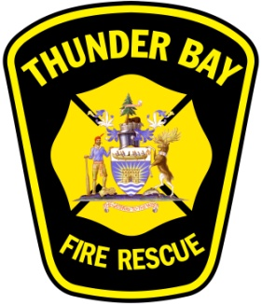

MEDIA RELEASE

www.thunderbay.ca/fire

Thunder Bay Fire Rescue Lifts Fire Ban

August 20, 2026 – Effective at 4pm today, Thunder Bay Fire Rescue has lifted the fire ban.
All recreational fire permits will be reinstated for burning starting at 5pm tonight.

The lift on the ban is consistent with the Ontario Ministry of Natural Resources and Forests Restricted Fire Zone declaration which will also be lifted as of 12:01am today.

Residents are reminded that all outdoor burning require permits in The City of Thunder Bay.

For more information on outdoor burning permits, please visit our website www.thunderbay.ca/fire or call 807-625-2103

Contact: Division Chief, Fire Prevention, Kevin Anderson
Thunder Bay Fire Rescue, 807-628-4921

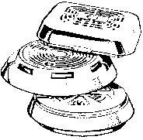
- 30 -
Smoke Alarms Save Lives

